STATIC ANALYSIS- RELIABILITY & USABILITY

*ArrayIsStoredDirectly
-Constructors and methods receiving arrays should clone objects and store the copy. This prevents that future changes from the user affect the internal functionality.
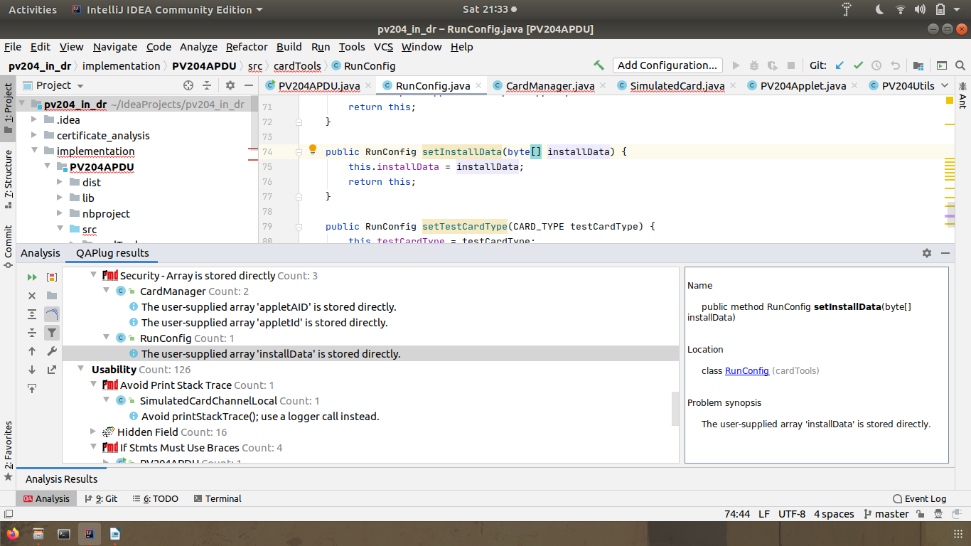

*IfStmtsMustUseBraces
-Avoid using if statements without using curly braces.
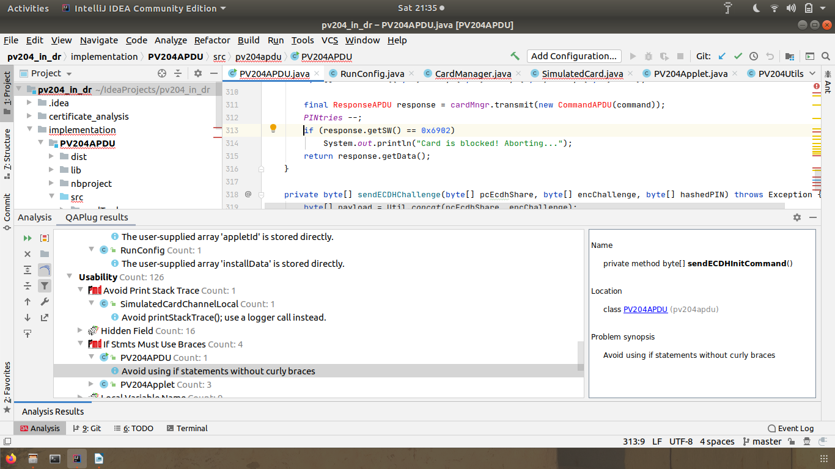

*StaticVariableNameCheck
-Checks that static, non-final variable names conform to a format specified by the format property.
